Exponential Functions:

- Definition

2. Graphs

Note: In the long run, exponential growth is faster than any polynomial/power
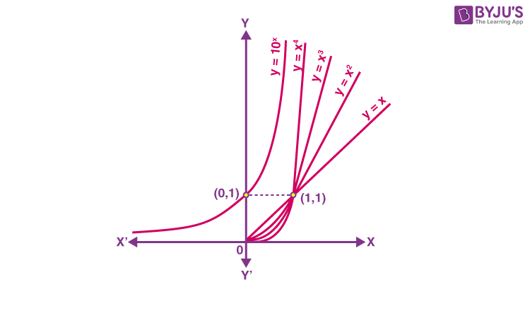
Paper folding Example

Folding a standard sheet paper a few times. How thick it would be after being folded 42 times?

If we fold a sheet of paper, one time, we double the thickness of the paper.

If we fold a sheet of paper, two time, the thickness of the paper is four times more than the original’s thickness.

Every time, we fold a paper, we double its thickness.

Question: How thick would it be after being folded 42 times?
Answer: It would be thicker than the distance from the earth to the moon!

How thick is a standard sheet of paper? 0.004 inches

The thickness of the paper after being folded x times is:

Y = 17592186044.4 (inches) = 277,654 (miles)

What is the distance between the earth and the moon: 238,855 miles

3. Two forms: base e and regular base, b

Mini-Break.

Class will be back in 20-25 minutes.

We will have an assignment at the end of the next session.

4. Solving Exponential Equations.

Log operator/function

Properties of Log

How to solve exponential equations using log:

Solving steps:
- Isolate the base
- Take the log of both sides
- Use logarithmic properties to simplify the expression and solve for x
- Round all answers to 4 decimal places

Example:

Solve:

Practice Problem (Assignment_Feb_25)

Solve for x

Take photos/screenshots of your answer and submit it to Canvas (Assignment_Feb_25).

